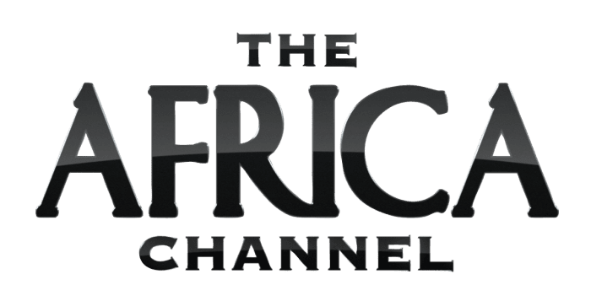

**THE AFRICA CHANNEL INC. ANNOUNCES SEVERAL NEW CONTENT AND RENEWAL AGREEMENTS;**

**COMPANY CONTINUES TO BE THE LEAD CURATOR OF AFRICAN PROGRAMMING FOR NORTH AMERICAN AUDIENCES ACROSS ITS PLATFORMS**

**LOS ANGELES, CA / MAY 15, 2023** – **The Africa Channel Inc.**, continuing in its role as the largest licensor of African content in North America with over 3000 hours, has reached several new content and renewal partnership agreements with some of the industry’s leading producers and distributors from the continent and beyond including BBC Africa, Cardova Trading Ltd, eTV, FilmOne, Inverleigh and M-Net. Show images available here: <https://www.dropbox.com/scl/fo/q31jzc9lzime8expkia87/h?dl=0&rlkey=rjqb03e1x0jl4gbe7ulxlk3pl>

The content will carried by the company’s two media platforms: [**The Africa Channel**](https://theafricachannel.com/) (**TAC**), a linear television network aims to demystify modern Africa for viewers in the Americas, and [**Demand Africa**](https://demandafrica.com/) (**DA**), the leading SVOD streaming destination for original and acquired content from Africa and the global Black Diaspora.

Said **Ava Hall**, **Head of Content & Brand**, **The Africa Channel Inc.,** “We are pleased to continue to support the company’s mission of both raising the profile as well as the economic inclusion of artists from the continent. Through a combination of licensing, minimum guarantees and generous revenue sharing arrangements, The Africa Channel continues to provide additional revenue streams to African content owners via the world’s most lucrative market. We are honored to be participating in these win-win content partnerships.”

New and recently concluded content partnership agreements for The Africa Channel and/or Demand Africa include:

* eTV: including ***Housewives***,multi-award-winning dramatic series
* Film One, ACI, Vision Films, for top grossing Nigerian feature films including: ***Banana Island Ghost*, *Bling Lagosians*, *Flower Girl*, *My Wife and I*,**and ***The Wedding Party***
* Inverleigh: ***The Rising*** – documentary series honoring black athletes.
* Action 4 Reel Filmworks: ***Queen Nanny: Legendary Maroon Chieftainess***
* Regency Fdn.: ***SA Inc*** – New Season, Renewal of existing Season
* MTV: ***Shuga*** – three new seasons of the multi-award-winning dramatic series
* Legacy: 30 hours of documentaries regarding such legendary figures as **Beyonce, Jimi Hendrix, Martin Luther King, Jr., Michelle Obama,** and **Tyler Perry**

Renewal content agreements for The Africa Channel and/or Demand Africa include new seasons of:

* BBC: ***Focus on Africa,*** the daily news from Africa and around the world, and ***Africa Eye***, award winning investigative documentary series.
* Cardova: ***Expresso*** - Renewal for new episodes of Africa’s #1 Live award-winning daily morning breakfast show marking a decade in business together
* MTV: ***Shuga*** - Renewal of 7 existing seasons of the multi-award-winning dramatic series.
* **MNET**: Renewal of existing content including multi-award-winning dramatic series ***Lockdown***, the reality formats ***Date My Family***, ***Wedding Bashers***, and ***Cooking with Siba*** and beloved soap series including ***The Wild***, ***Battleground***, and ***Tinsel*.**

Over the last 18 years The Africa Channel and Demand Africa have become the most widely distributed platform for Pan African content in all of North America across all media − Cable, SVOD and FAST – while steadily building a demand for African content in the U.S. The network’s original programming such as the upcoming series ***African Royale***, and past shows such as ***World Wide Nate*, *Amah Knows Best*, *Africa Everywhere*** and ***Made BKLYN*** continue to bring stories of the African Diaspora to worldwide audiences.

**About The Africa Channel**

The Africa Channel is a linear television network that aims to demystify modern Africa for viewers in the Americas. Available via pay TV distributors across the U.S., Canada and the Caribbean, The Africa Channel entertains and informs audiences with original series, movies, documentaries and specials as well as current affairs, soaps and cultural programming.

Viewers can watch the company’s flagship linear channel via pay TV distributors across the U.S., including Charter’s Spectrum, Comcast and Cox Communications, as well as in Canada on Rogers Ignite and Bell Fibe and in the Caribbean via the Caribbean Cable Cooperative. It is part of The Africa Channel Inc.

**About Demand Africa**

Demand Africa, a subsidiary of The Africa Channel Inc, is a global OTT and streaming video service connecting audiences to the best lifestyle, movies and TV from Africa and beyond. Demand Africa’s mission is to celebrate and amplify modern Africa’s influence on the world by connecting global audiences to entertainment as diverse and bold as the continent itself. Demand Africa is available as an add-on subscription service on Amazon’s Prime Video Channels and The Roku Channel; as a standalone subscription video on demand (SVOD) app for mobile (iOS, Android), and connected TV (Amazon Fire TV, Android TV, Apple TV, Roku) devices; and as a free ad-supported streaming television (FAST) channel distributed via several owned and third-party platforms around the world.

**About The Africa Channel Inc.**

The Africa Channel Inc. is a media company whose sole mission is to celebrate the diversity of culture from across today’s Africa, serving audiences that are interested in the Global Black Diaspora. The Africa Channel Inc. has offices in Los Angeles and Johannesburg, South Africa and through its platforms offers several thousand hours of content through which audiences can explore the culture, people, places and traditions of Africa.

**Media Contacts:**

Don Ciaramella / Matt Biscuiti

The Lippin Group

+1.212.986.7080

[tac@lippingroup.com](mailto:tac@lippingroup.com)